Biome Name: _______________________________ Team Members ________________________
World Location: ________________________
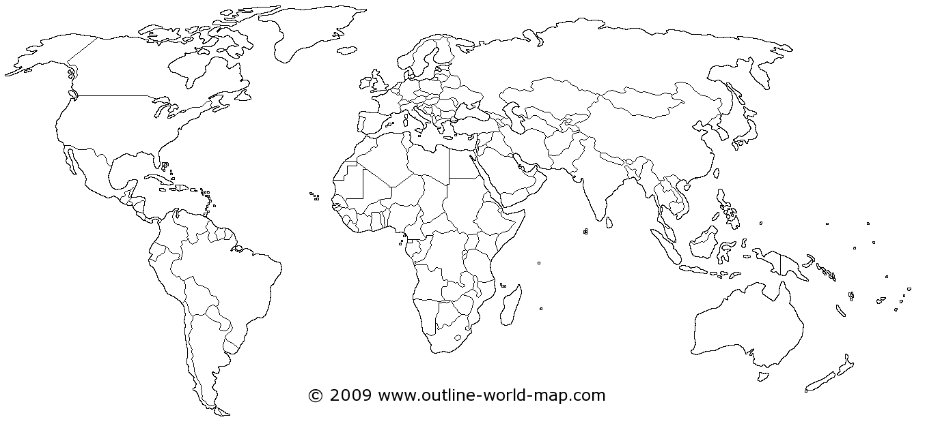
Other Environmental Factors (soil, tides, landforms, bodies of water etc.):

Climate (Average Annual Temperature, Seasonal Temperatures, and Precipitation):

Plants:
•
•
•
Animals
•
•
•
Food Chain
____________ _____________ ____________ _____________

